1) Add ad instance of prefab "Level" to scene "Sample Scene"

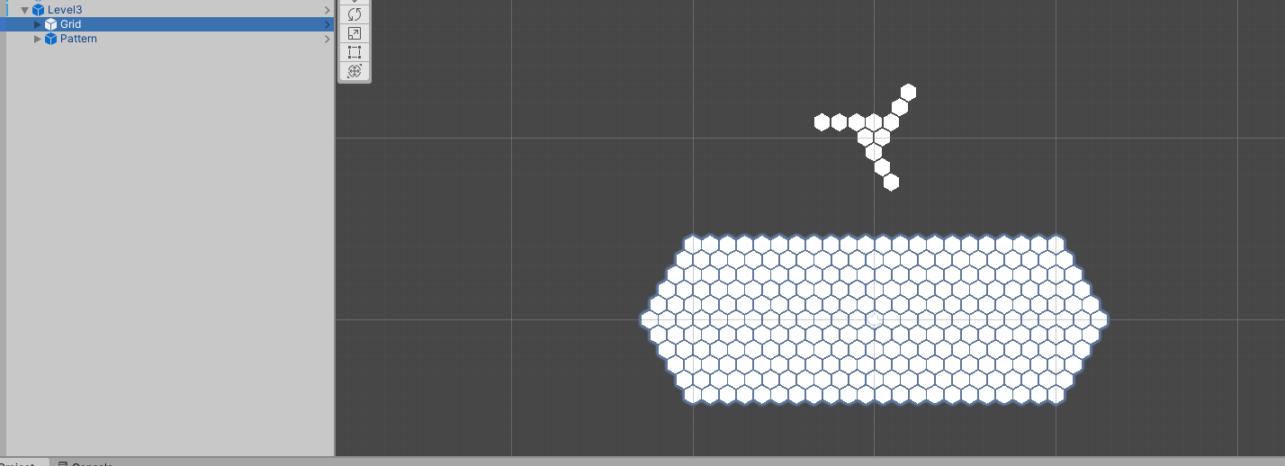

2) Select "Grid" or "Pattern" object ot edit level grid or pattern, both of them have "Hex Grid" script component.

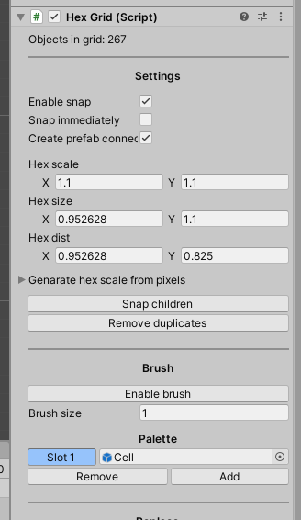

3) Press enable brush to start painting new cells. Press LMB in Unity's Scene view to paint a cells. You can continue drag and paint for as long as you want.

4) Add an empty slot to Palette and switch to it to erase cells, which are already painted. Press LMB on existing cell in Scene view to erase. You can continue drag and erase them for as long as you want.

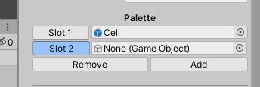

5) Please, make sure not ot apply changes to initial Leve, Grid or Pattern prefabs. Leave all of them in "override" mode in editor.

6) Do not forget to save your changes.